Career Application

Empowering Families, Transforming Lives

All positions at Kids Matters OT are an integral part of the success and smooth operations of the business. Our goal is to put you in a position that keeps you challenged, is fulfilling, has you engaged and helps you achieve your career goals.

Please complete the following application with total honesty. There are no right or wrong answers. We just want to ensure that we are a right fit for you, and you for us.

Name
Address
Email
Phone
Date
Position Applied for

Kids Matters Occupational Therapy

Our Why/ Purpose
To be a safe and supportive community so that we all grow in confidence, connection and live our potential.

(clients and staff)

The Way we do (How)
- We do people first.
- We meet people where they’re at.
- We are truly present and listen to each other.
- We are playful in our approach.
- We give and receive hope and guidance.
- We have understanding and compassion.
- We live our culture code.

Our Vision

To ensure equal access to quality OT and allied health care around Qld (including rural areas).

Our Culture Code
- Connection
- Collaboration
- Quiet Mastery
- Playfulness
- Excellence

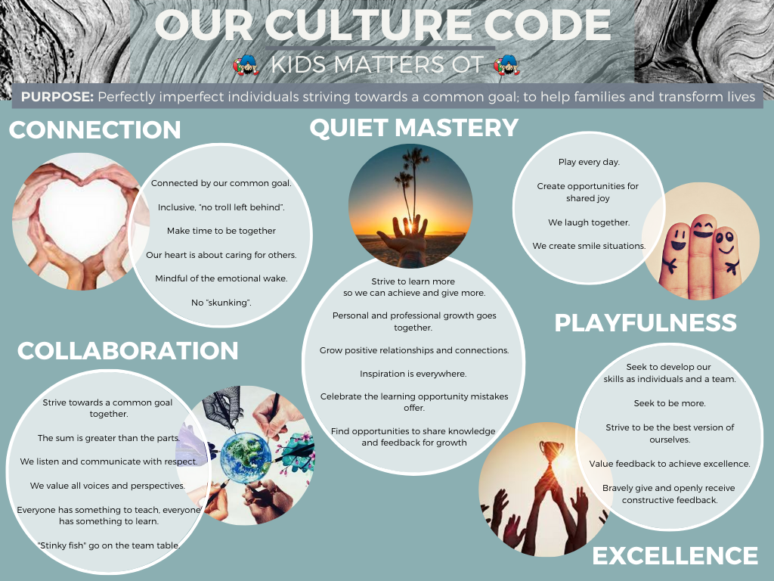
Career History

Please read these instructions carefully before completing the following section on Business/ Career Experience. This information will not be the only basis for hiring decisions. You are not required to provide any information that is prohibited by law.

In the business/ Career Experience section, each letter (A, B, C, etc.) corresponds to a specific job. If, for example, your present employer is “Total Rehab solutions” and you have had three different jobs, each with a different job title with “Total Rehab solutions”, please list them separately.

- Please complete a section of this form (A, B, C, etc.) for every job where there was a change in your job title.

- Begin with your present, or most recent, job and progress backward in time going from A to B to C, etc.

- This form is set up for 6 job titles, A-G. If you have had more than 6 jobs, please attach a separate sheet outlining those additional jobs formatted like jobs D-F. If you have had less than 6 jobs, leave the remaining spaces blank.

- For each job you are asked to estimate how your final employer/ supervisor would rate your overall performance on a scale of Excellent, Very Good, Good, Fair and Poor.

- At an appropriate time, we may ask you to arrange personal reference calls with employer/ supervisors you’ve had.

Business/ Organisation/ Career Experience
Please start with your present or most recent position. Reminder: Do not combine jobs. Fill out a complete section of this form for every job where the job title has changed. These can include paid or volunteer positions.

Work Experience – A
Business/ Organisation Name
Kind of Business/ Organisation
Employed from | (month/ year)___________To (month/ year)___________
Title/ Position
Starting Salary
Final Salary
Name of Supervisor
What do (did) you like most about your position?
What do (did) you least enjoy?
Reason for leaving
Other comments:
Work Experience – B
Business/ Organisation Name
Kind of Business/ Organisation
Employed from | (month/ year)___________To (month/ year)___________
Title/ Position
Starting Salary
Final Salary
Name of Supervisor
What do (did) you like most about your position?
What do (did) you least enjoy?
Reason for leaving
Other comments:
Work Experience – C
Business/ Organisation Name
Kind of Business/ Organisation
Employed from | (month/ year)___________To (month/ year)___________
Title/ Position
Starting Salary
Final Salary
Name of Supervisor
What do (did) you like most about your position?
What do (did) you least enjoy?
Reason for leaving
Other comments:

Education
Tertiary
Name of Institution
Qualification/s
Name of Institution
Qualification/s
Other Post Graduate Education

What formal skills and experience would you bring to your position at Kids Matters?

Skills/ Experience
Speaking in public

Competency with technology

Building and maintaining a caseload
Age ranges from 0-Adult that you have skills and interest in treating.
Disability and condition groups that you have skills and interest in treating.

Your Professional Development
Tell us about the training you have undertaken in the past 12 months, outside of work hours that have helped advance your contribution and value to your career.

Area | Comments
Professional special interests (e.g. books, podcasts)
Seminars/ workshops/ conferences
Membership in professional or job-relevant organisations.
Publications or additional special honours or awards you have attained.
Other:

Work Skills
In the table below, please give a personal rating between 1 and 5 of where you think your attitude lies. Just circle the most appropriate number.

Attribute |  | Rating
Organisation | I live life moment by moment. | 1…2…3…4…5 | I plan every hour of my day
Time Management | I never have enough time to do the things I have to or want to. | 1…2…3…4…5 | I always make time for work, rest and play
Handling Pressure | I often feel pressured by the amount of work I have to do | 1…2…3…4…5 | I have effective tools for managing pressure
Career Attitude | I work so I can make money to enjoy life outside work. | 1…2…3…4…5 | Other factors such as professional development work culture and job satisfaction are very important to me.
Handling feedback and possible confrontation | I don’t like regular evaluation and/ or feedback. | 1…2…3…4…5 | I welcome regular feedback and value open communication as an opportunity to grow.
Teamwork | I prefer to work by myself. | 1…2…3…4…5 | I thrive when working in a team environment.
Productivity | I find it difficult to effectively prioritise my time. | 1…2…3…4…5 | I am good my prioritising my time in a busy caseload. I am realistic about what I can do.
 | I blame other people or justify if I make a mistake. | 1…2…3…4…5 | I take full responsibility for my
Positivity | I prefer to discuss problems and complaints with my colleagues and I enjoy a bit of office gossip. | 1…2…3…4…5 | I only discuss problems with people who are part of the solution, and avoid gossip and small talk about other people.
Accountability and Responsibility | I blame other people or circumstances for my failures | 1…2…3…4…5 | I am fully accountable for the results that I produce in my life. I see all mistakes as learning opportunities.

Projects/ Tasks
These are the projects that happen regularly in the business. Depending on your role/ position you will need a general understanding of some of the following. Please identify your honest likes and dislikes in all of the following areas. Again, there are no right or wrong answers.

Activity | Love it | OK | Dislike it | Comments
Creating systems to make the workplace run more smoothly

Following systems and procedures
Working within a close-knit team
Caring for clients and their families
Converting assessments to therapy
Saying no to people when required
Calling referrers and other professionals
Calling parents and teachers
Supporting/supervising junior therapists
Conducting school or home visits
Helping other team members with scoring and reports if quiet
Writing progress notes according to set format
Writing reports and treatment plans according to set format
Making sure that facilities are neat and tidy & cleaning up after yourself
Occasional work social events outside 9-5 hours for team building and connection

A bit about you personally…

Question | Answer
If money wasn’t an issue and you could have any job or career you wanted, what would you absolutely love to do?

In the next 3-5 years, what career goals do you have?

What is your salary expectation?

What are the most important things for you to have in your life on a regular basis?

What hobbies/interests do you have?

Do you have the support of your partner, family, friends when it comes to your career/job?

Do you have any other things that you would like to tell us about yourself, personally?
……………………………………………………………………………………………………………………………………………………………

……………………………………………………………………………………………………………………………………………………………

……………………………………………………………………………………………………………………………………………………………

……………………………………………………………………………………………………………………………………………………….…..

A bit about you professionally…

Question | Answer
I am happiest when….
My greatest career satisfaction comes when...
I am most proud of myself because…

What qualifications, abilities and strong points will help you succeed in this job?

What are your weak points or areas for improvement?

In a work context, the mistakes that I have made that have taught me the most are….

In a work context, the things that frustrate me are…
The thing/things that can hinder my progress are...
The emotion I find the most difficult to control is…
In a group I usually get most involved when…
When I think about the future I see myself…

Do you have any other things that you would like to tell us about yourself professionally?
……………………………………………………………………………………………………………………………………………………………

……………………………………………………………………………………………………………………………………………………………

……………………………………………………………………………………………………………………………………………………………

……………………………………………………………………………………………………………………………………………………………

……………………………………………………………………………………………………………………………………………………………
A bit about your clinical reasoning and knowledge…
Please indicate your level of knowledge and experience in the following areas:
 | Level of Experience
Area of Expertise | None | Little | Some | Extensive
* handwriting issues

* sensory processing

* motor coordination difficulties.

* learning difficulties

* low level Autism

* high level Autism/ Aspergers syndrome.

* toileting

* self-care issues

Executive function
Behaviour management
E
Emotional Regulation

Please give comments as you would like...
________________________________________________________________________________________________________________________________________________________________________________________________________________________________________________________________________________________________________________________________
The final details
Do you have the legal right to work for any employer in Australia
- Yes
- No

Would you be willing to arrange reference calls with supervisors you’ve had in the past few years, as one of the steps prior to a final job offer?
- Yes
- No

I certify that answers given in this Career Application form are true, accurate and complete to the best of my knowledge. In the event that I am employed, I understand that any false or misleading information I knowingly provided in my career Application Form or interview/s may result in discharge and/or legal action.

I understand that if employed by Kids Matters OT, I am required to abide by all policies and procedures of Kids Matters OT and any special agreements reached between Kids Matters OT and me.

Signed: ___________________________ Date:_______________________

