JUMP & REMEMBER
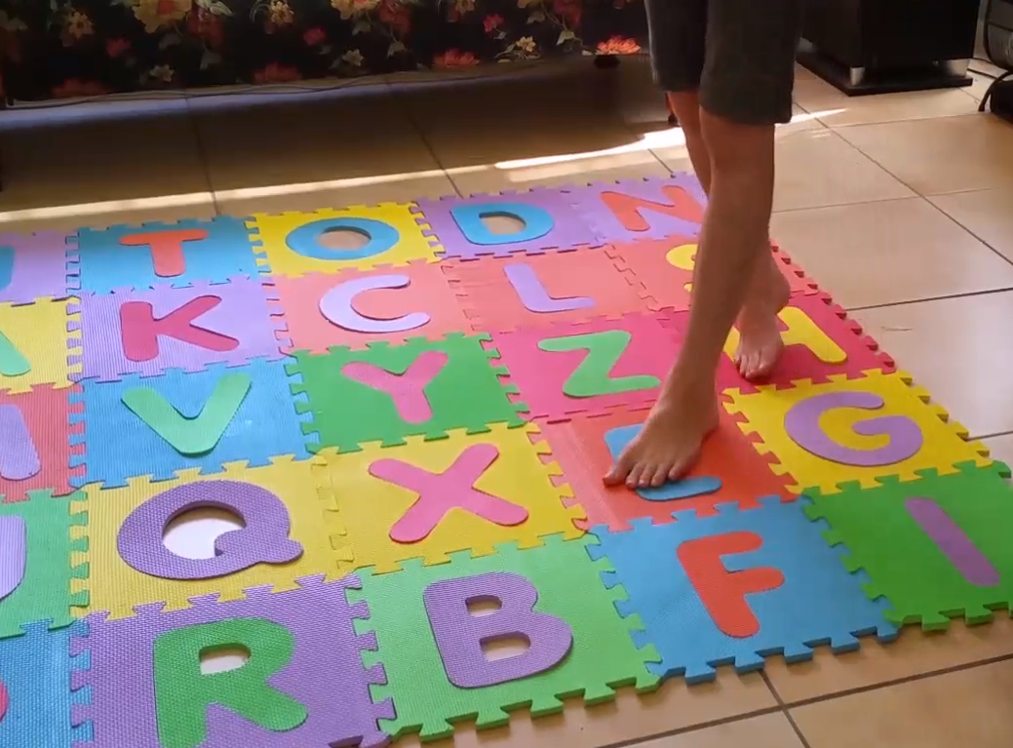
Set Up
Make a square divided into 9-16 parts on the concrete with chalk (or if you have them, use foam letter or number tiles). If drawing write out any individual numbers and/or letters you like, or you might like to choose short words if your child can read (no more than 3-4 letters).
How to Play
The game is for you to call out random numbers, letters or words that you have entered into each square.
Your child waits until you are finished then has to jump on them in the order they were called out. Start with 2 items to be sure they understand first.
Don’t repeat the sequence if they forget – just give them another one. If they fuss say “It’s the rule!” with a shoulder shrug.
Go up a level after 2-3 successes at one level, and drop down to the lower level after 1-2 errors depending on your child’s frustration tolerance. We want to keep it fun! Always finish this game on a win. This is a game about personal bests.
Variations:
- Your child not a jumper? They can kneel and touch in order, or walk on them, or toss a bean bag or soft toy.
- Negation – when using pictures to jump on, have them only jump on some of your list e.g. Jump on the dog, cat, and the fish, not the horse.
- Have them move on the numbers/letters in reverse order or re-organize from lowest to highest or in alphabetical order

