LILY PAD or JUMPING FROGS GAME

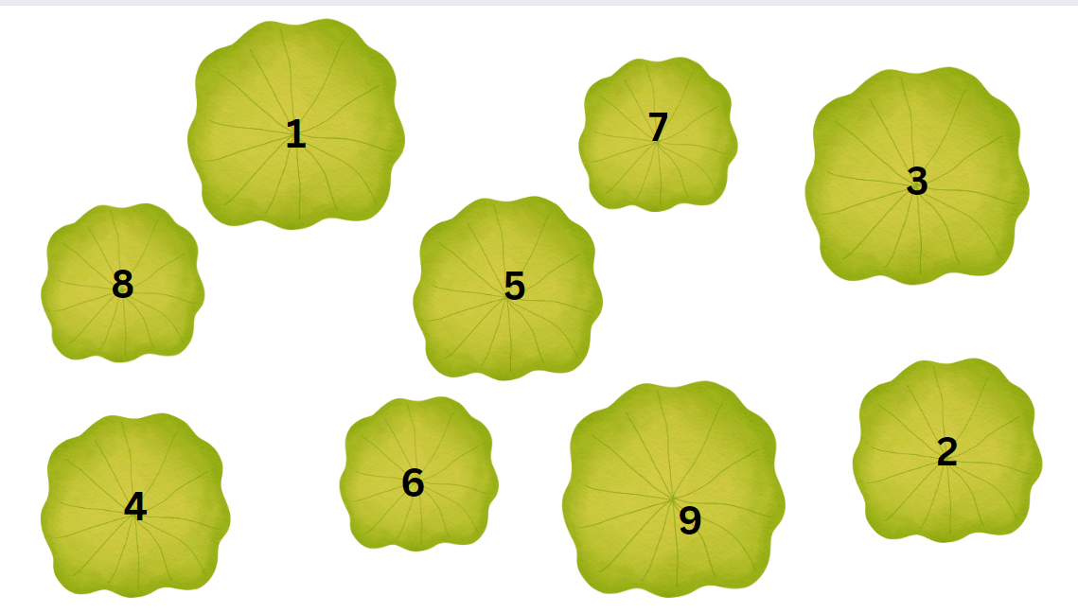
Set up
What you need is something with which to draw and something to draw on – the surface is up to you. This can be a finger on paper game or a hopping, jumping or walking game, depending where you draw it.
Draw “lily pads” in a random arrangement. For extra cues you can write numbers or letters on them.
How to Play
The game is to for one player to lead the way to complete a sequence, touching the selected lilypads. Once the first frog is done with the sequence, then the other frog follows the same sequence. Start with just 2 lily pads first, then increase by 1 when they get this right. When you reach a level where they make 2 mistakes in a row, drop back to the previous level until they get it, then try again at that higher level. If they miss it again, drop back down and finish the game.
Make sure to swap roles (they love to lead the way).
Variations
- You can call the numbers instead of touching them.
- You can mix up a variety of letters and call out a words that your child needs to spell. When they get one right, it’s your turn (give them a list of words that are hard for you to spell)
- For older children, call out a large number such as “3215” that they must reproduce in the right order from lowest to highest e.g. “1235”

